Reasonable adjustments

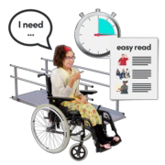Reasonable adjustments are small changes that can help people with a learning disability be treated equally.

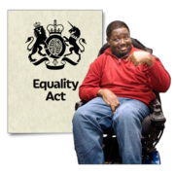The law says that reasonable adjustments should be put in place.

It is your right to ask for reasonable adjustments when you have an appointment for your health.

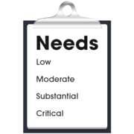Reasonable adjustments could be the way that the staff treat you, or things that you need when you are at your appointment.

Every person is different and will need different changes but there are some which are more common.

**Examples of reasonable adjustments that you could ask for:**

Staff who speak clearly and use easy words

A hospital passport which tells people all about you

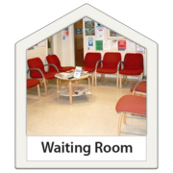A quiet place to wait, or a private room

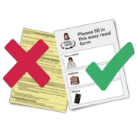Easy read information

An appointment at a time which is better for you

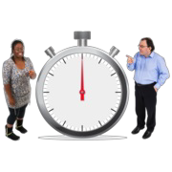Having your appointment on time

Support workers or family members with you

Help from a learning disability nurse

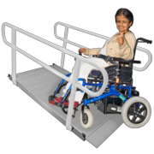Better physical access and help to get around

Staff may have already put reasonable adjustments in place for you, but it is important that you tell them if you need anything else.

It is your right to ask for reasonable adjustments.

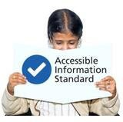If you want to know about how to get more understandable information from health and social services, read the [Accessible Information Standard](https://www.mencap.org.uk/easyread/accessible-information-standard-ais) easy read.

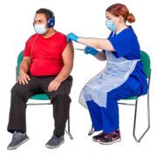If you are having a vaccination, we have made an easy read about the [vaccine reasonable adjustments](https://www.mencap.org.uk/easyread/vaccine-reasonable-adjustments) you could ask for.



Last updated 21.02.2023